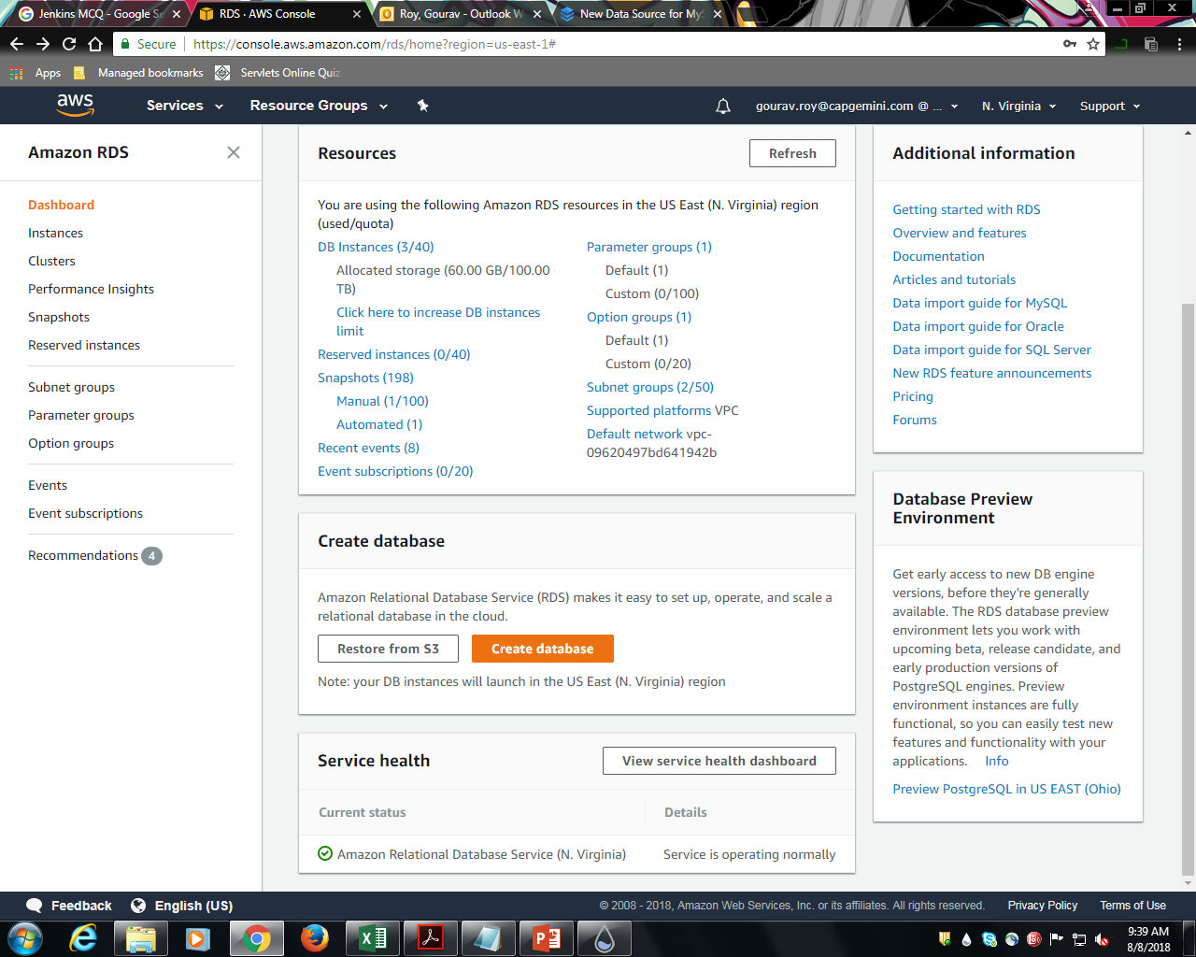

Step 1. Search for RDS in AWS console.

Step 2. Click on Create Database.

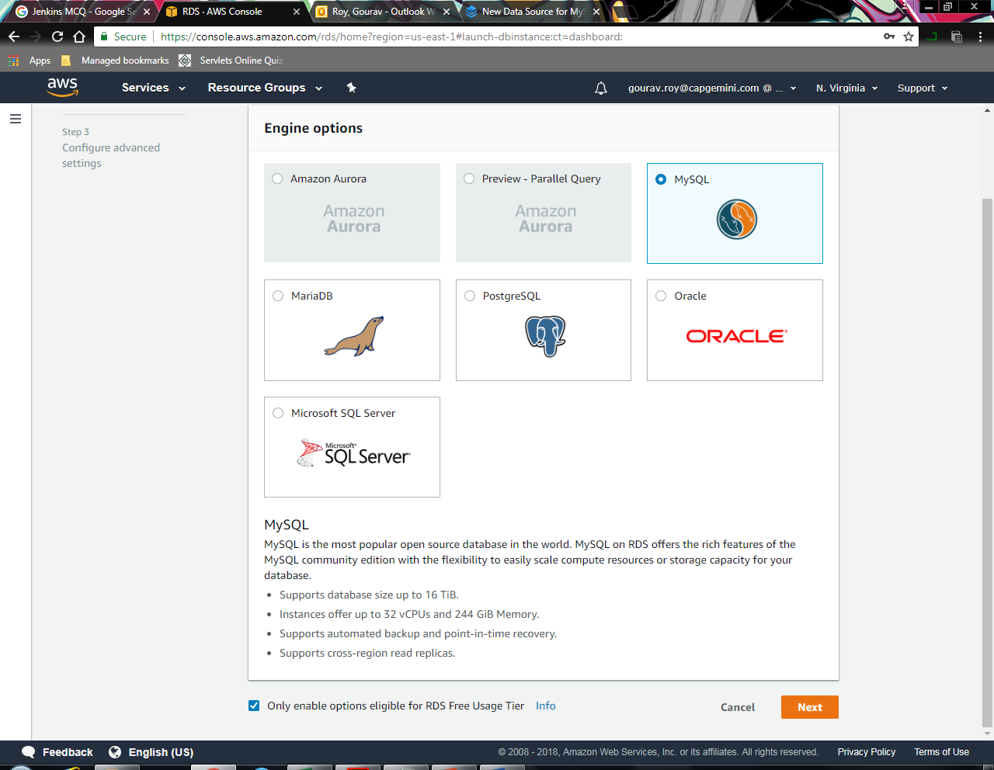

Step 3. Check “Only enable free tier” .

Step 4. Select MySQL.

Step 5. Click Next.

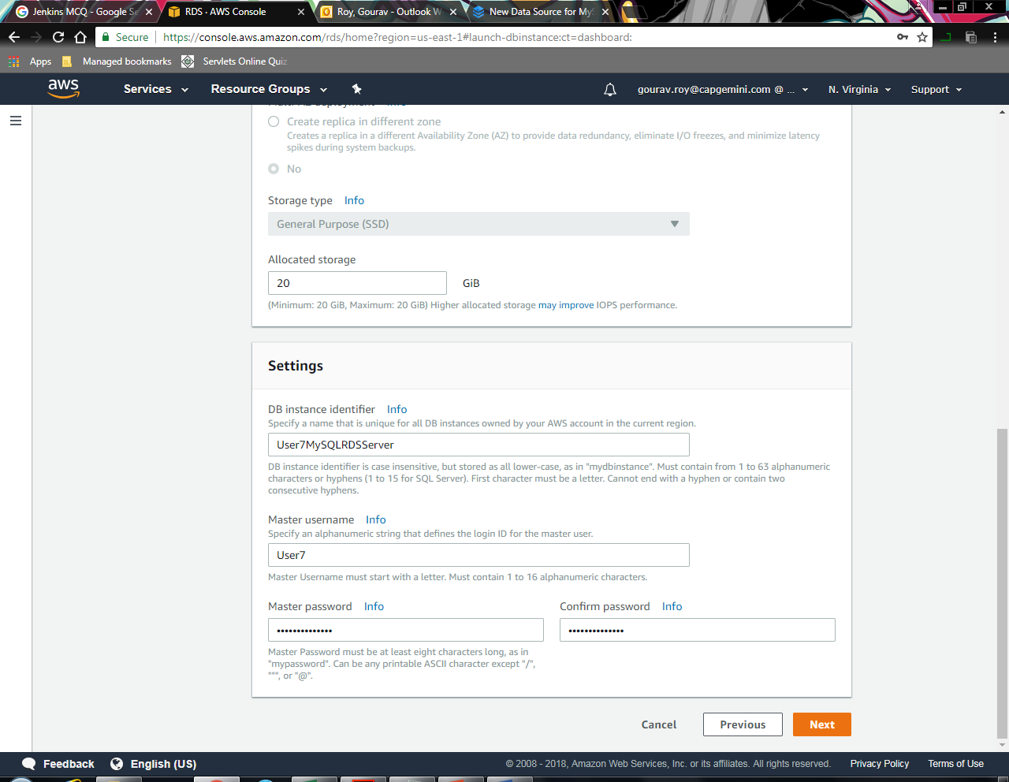

Step 6. Enter a) DB Instance b) Username and c ) Password.

Step 7. Click Next.

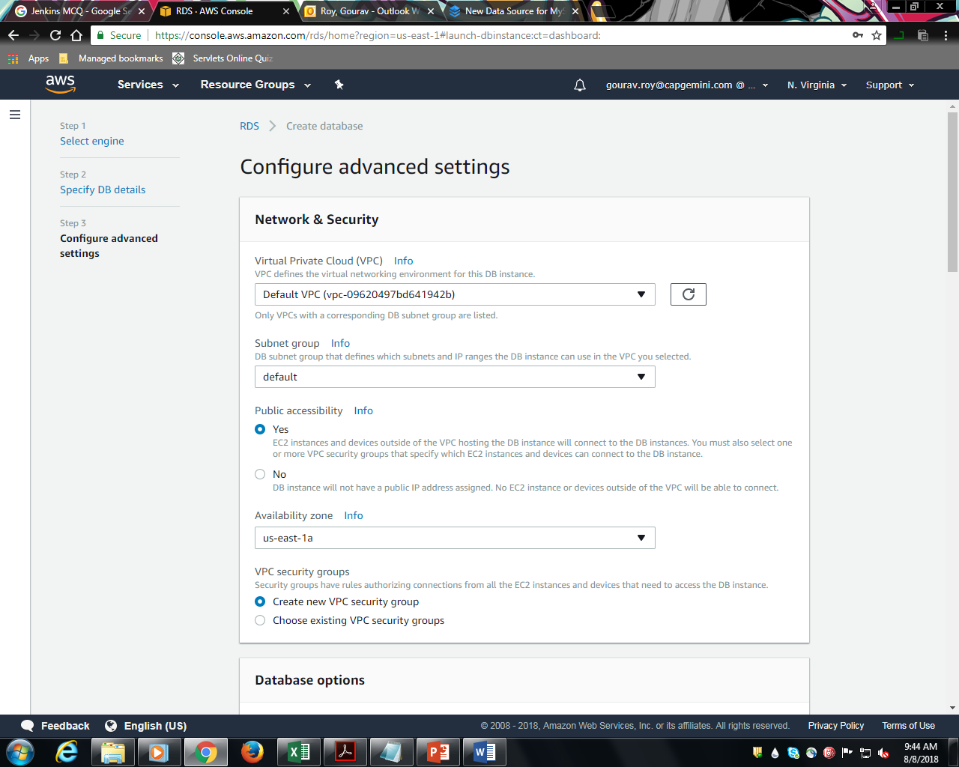

Step 8. Select “Yes” for public Accessibility.

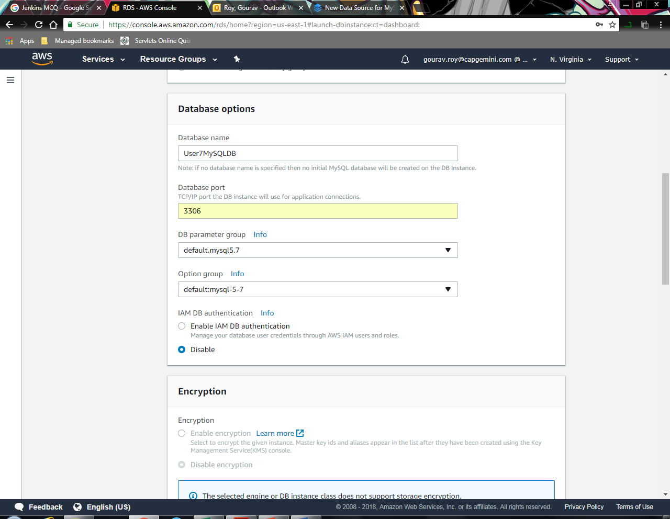

Step 9. Enter Database name.

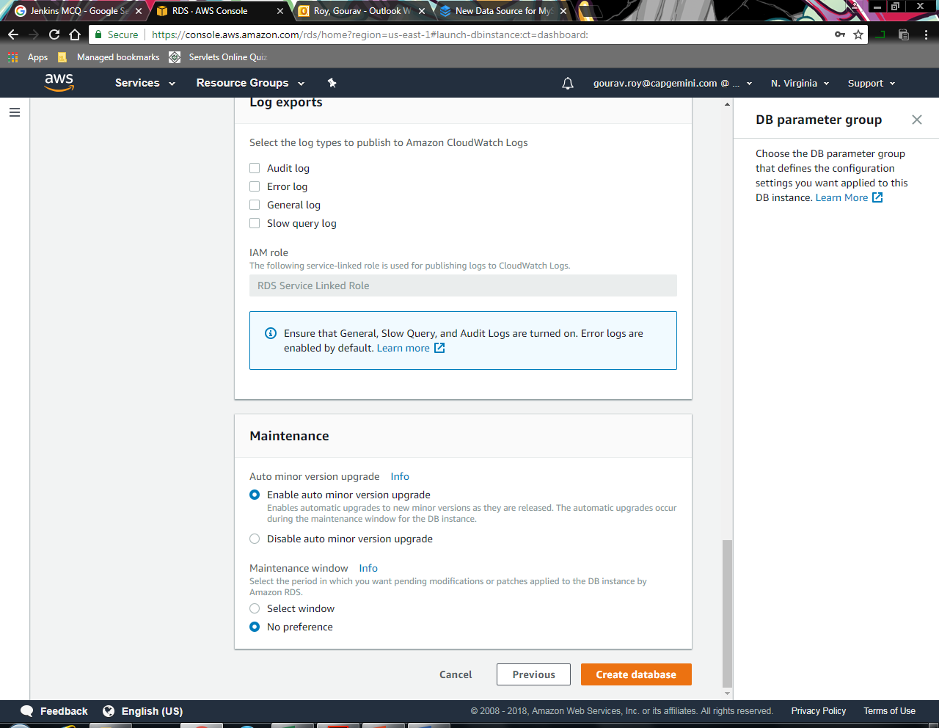

Select 10. Click Create Database.

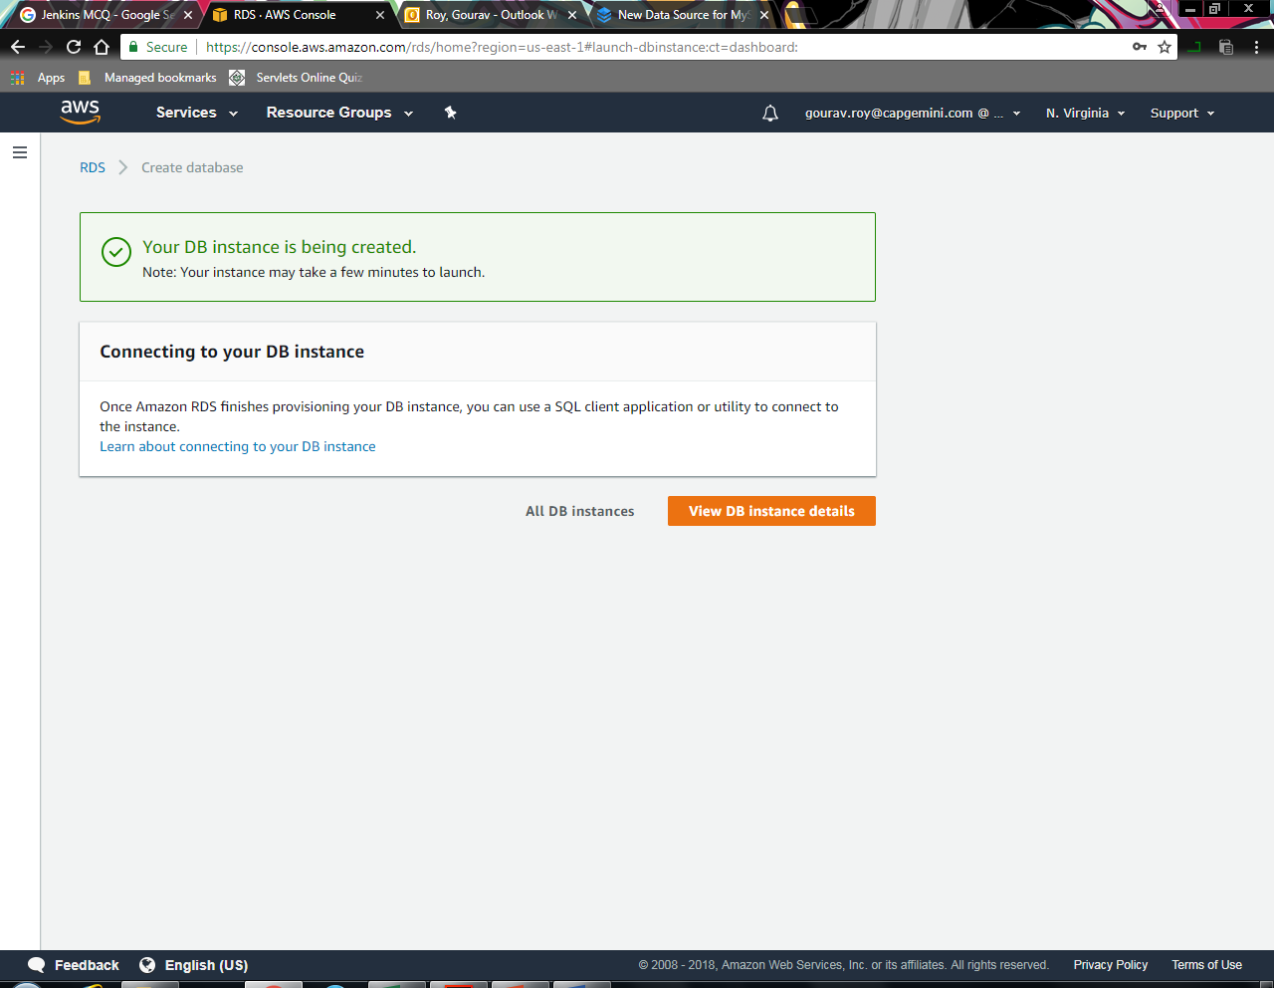

RDS Instance Created Successfully.

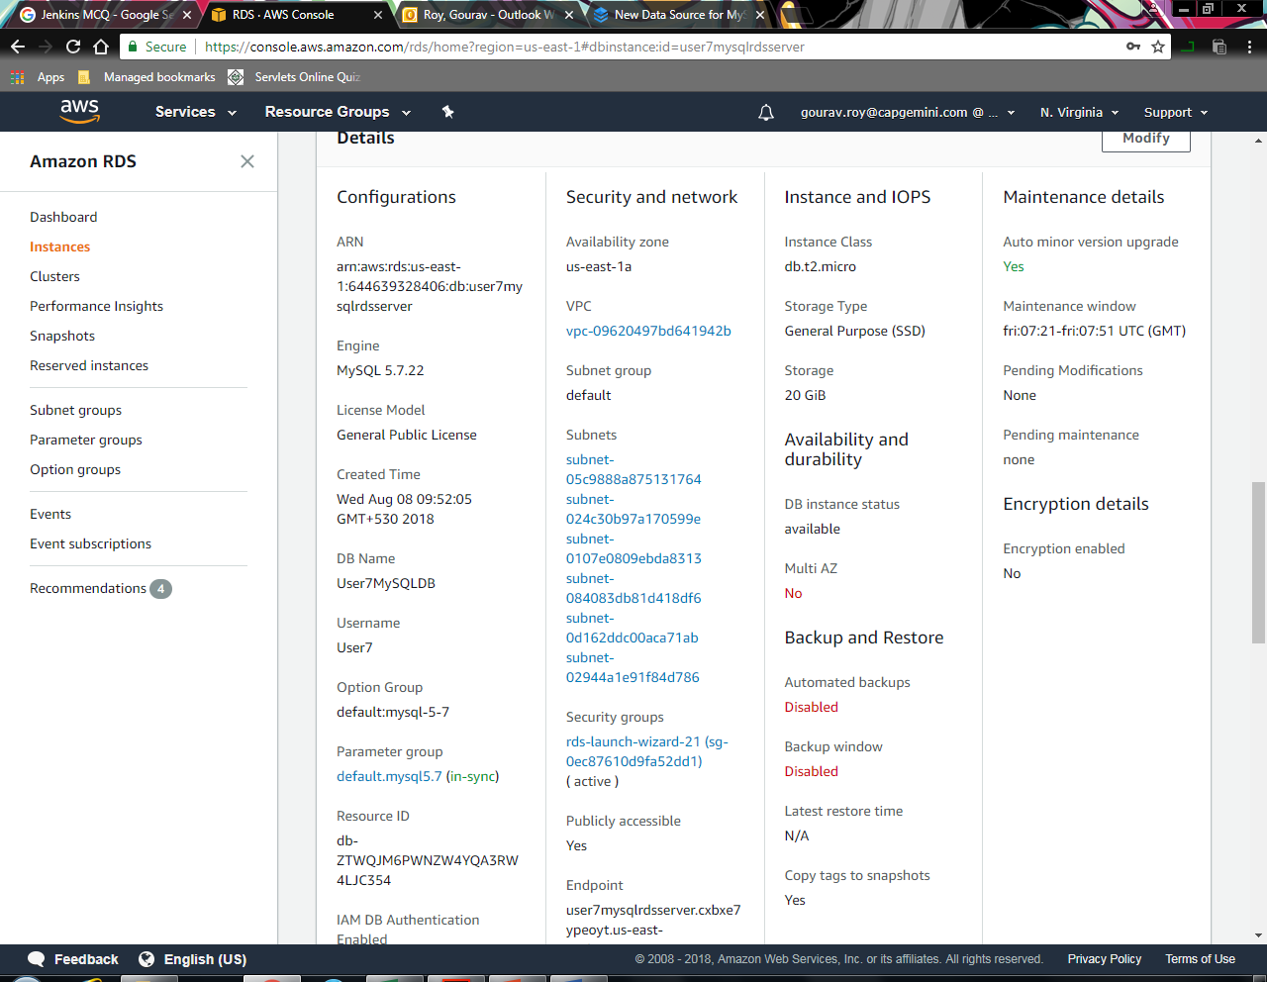

Step 11. Keep a note of “Endpoint”, “Database name” , “Username” and “Database Password” (Enter earlier ).

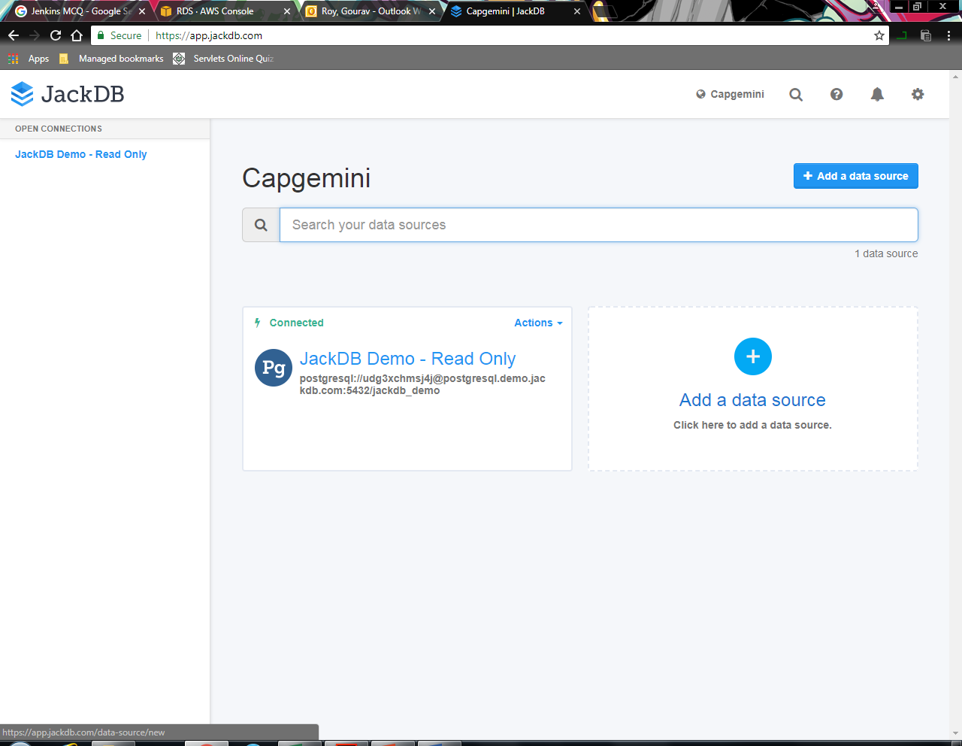

Step 12. Create a account on JackDB and login.

Step 13. Click on Add a data source.

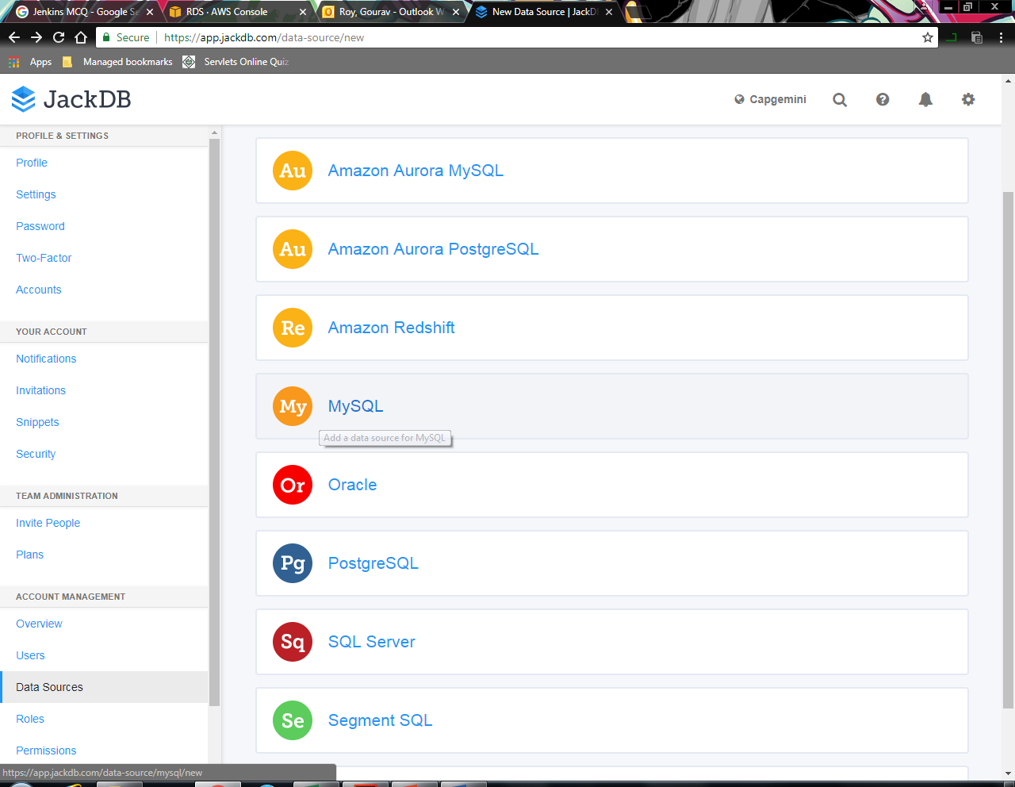

Step 14. Select MySQL.

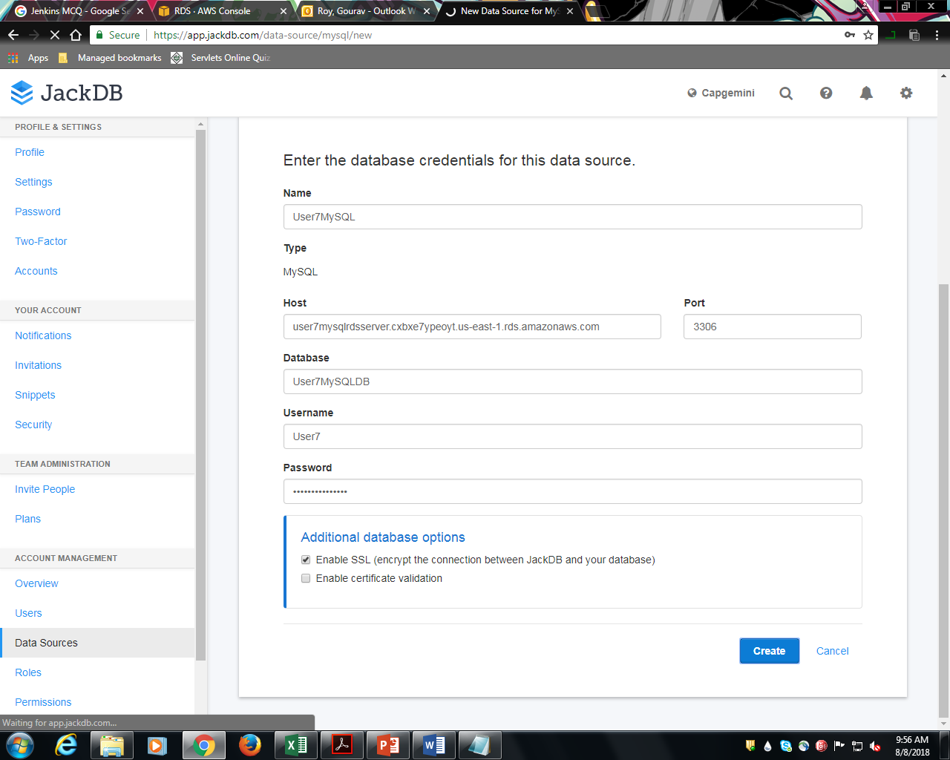

Step 15. Enter the Required info noted earlier.

Step 16. Click on Create.

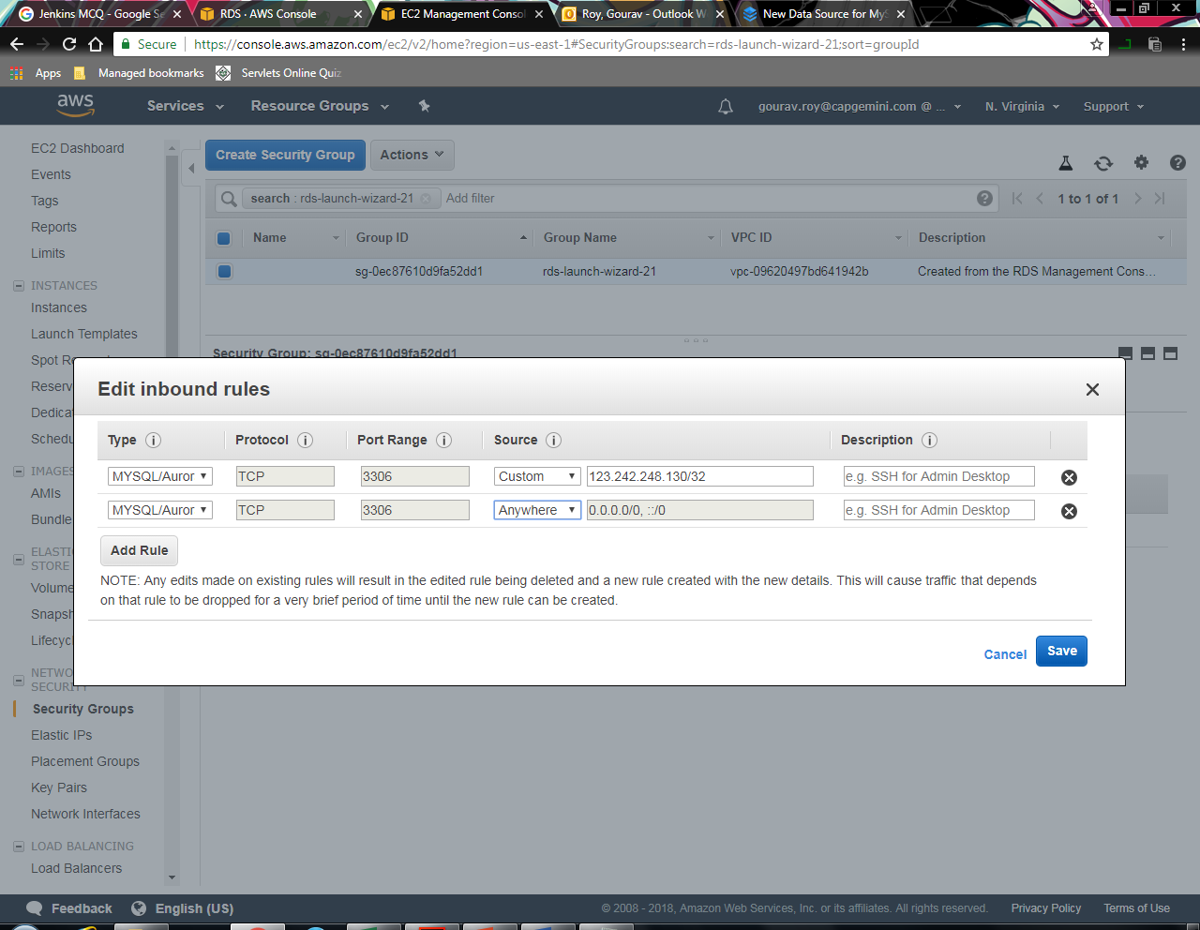

Step 17. Goto Security Group and Edit inbound Rules

Step 18. Select Type= “MySQL/Aurora”, Source=”Anywhere”

Step 19. Click Save.

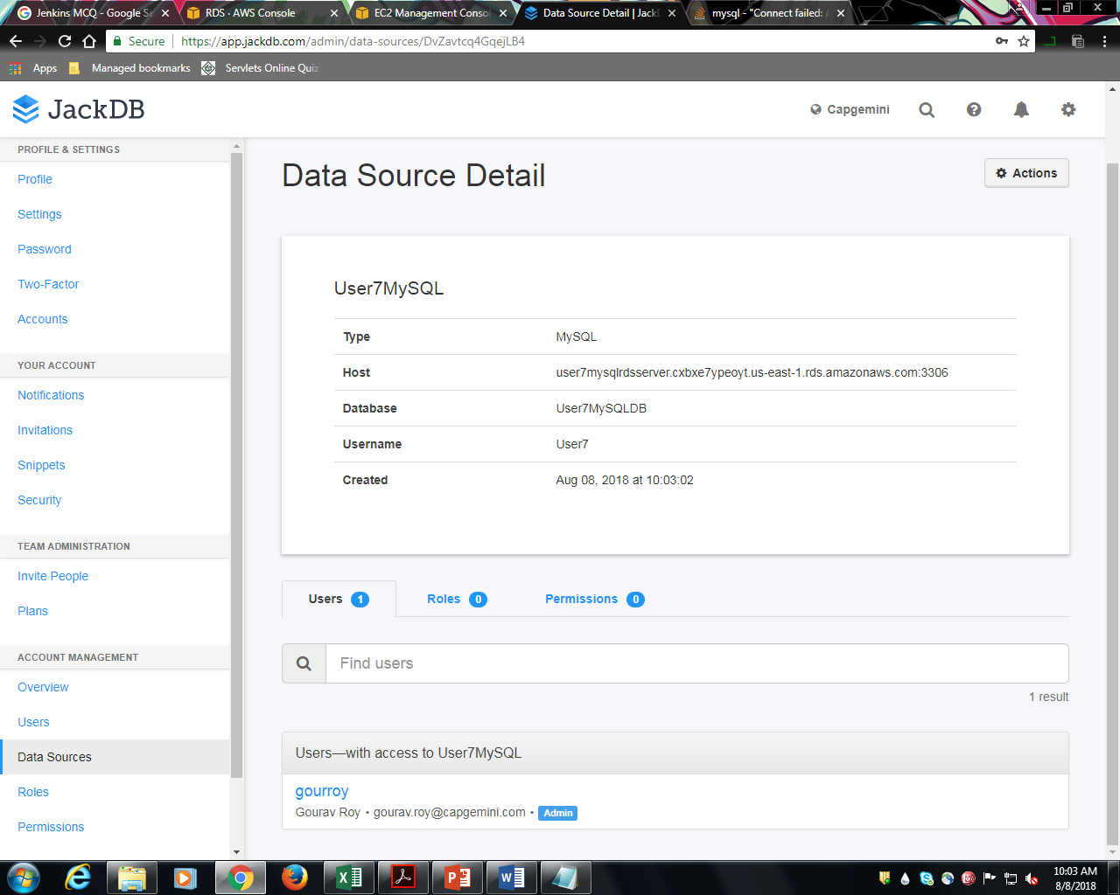

Step 20. If Editor console does not appears itself, Click on Actions -> Connect.

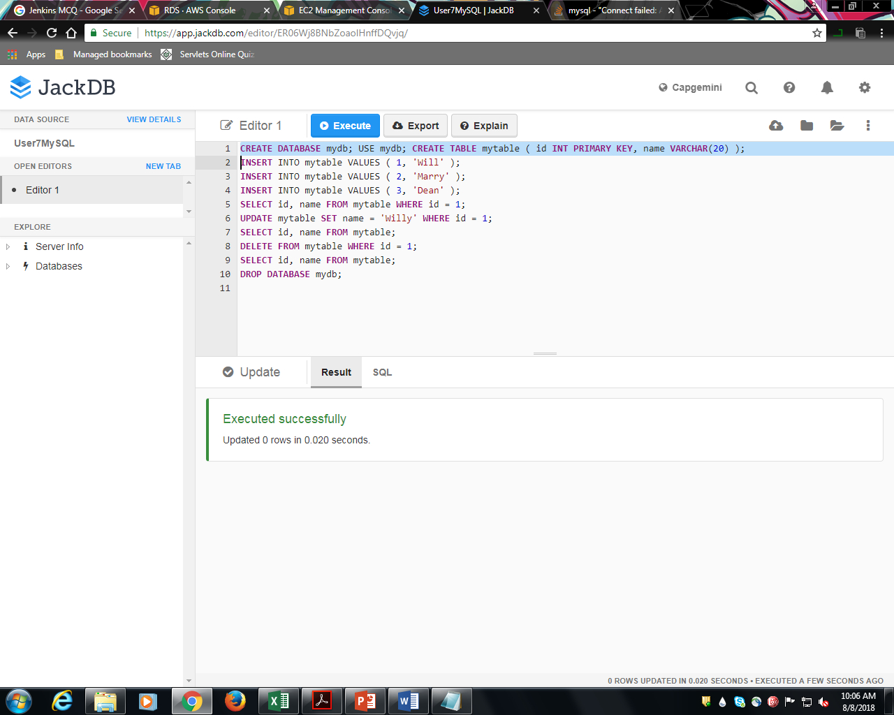

Step 21. Enter the SQL commands then click on Execute.

Step 22. To execute a particular query , select the query and click on Execute.

